MiSACWIS Project

CF02 – Identify On-Call Staff UCR

Version 0.4

December 8, 2011

Prepared for:


120 N. Washington Square
SACWIS Project, 3rd Floor
Lansing, MI 48933

Prepared by:

Revision Log
Version | Date | A/D/C (Add, Delete, Change) | Author | Document Section # | Description
0.1 | 07/18/2011 |  | Matthew McElver |  | Initial Version
0.2 | 12/05/2011 | A | S Kulkarni | 4.1 | CRUD Matrix
0.3 | 12/07/2011 | A | S Kulkarni | 2 | Added Class Diagram
0.4 | 12/08/2011 | C | S Kulkarni | 2 | Class Diagram

Table of Contents
1 Introduction 5
1.1 Purpose 5
1.2 Scope 5
2 Class Diagram 6
3 Sequence Diagrams 7
4 Business Data Dictionary 8
4.1 CRUD Matrix 8

List of Figures
Figure 1 – Class diagram 6

Introduction

Purpose
This Use Case illustrates the process of creating a monthly On-call schedule of Employees for a specified business purpose.

Scope
This schedule displays the hours that a particular Employee is responsible for business coverage either during business hours or off peak business hours. Organizations have the flexibility of designating an employee for providing On-call support for a certain period. A backup person can also be designated. This Use Case also describes the process for viewing this schedule by a Worker.

Class Diagram
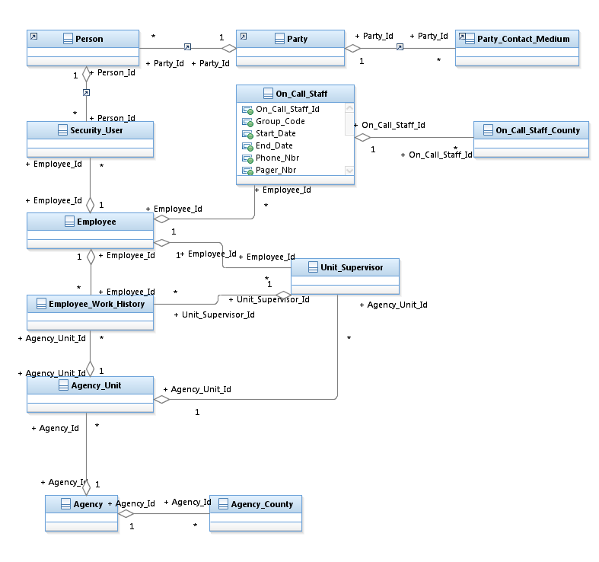
Figure 1 – Class diagram

Sequence Diagrams

- Business Data Dictionary
  - CRUD Matrix

Class | Create | Read | Update | Delete
Agency |  | X | X
Agency_County |  | X | X
Agency_Unit |  | X | X
Employee |  | X | X
Employee_Work_History |  | X | X
Person | X | X | X
Party |  | X | X
Party_Contact_Medium |  | X | X
On_Call_Staff | X | X | X | X
On_Call_Staff_County | X | X | X | X
Security_User |  |  |  | X
Unit_Supervisor |  | X | X

